Step 0 Intake + Interview Filing Status, Dependency
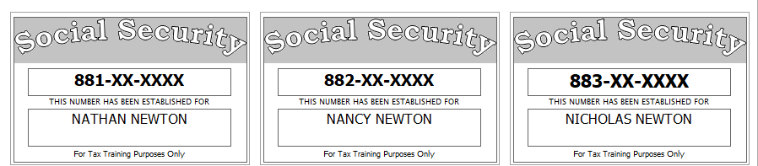
[Driver’s Licenses go here…]
Before starting the return in TSO, you examine SS cards and picture id, review and correct the Intake Sheet, examine the prior year return, and examine and sort all tax documents. You also ask probing questions to determine dependency status and the appropriate filing status.
You can start filling out the NJ Checklist and the NJ HCC / SRP Worksheet at any time.
Notes from examination of prior year return:
- They did not itemize last year
- They received a tax refund last year of $213 on their federal return and $200 on their NJ return
Extra interview information for NJ:
- Contribution to the Gubernatorial Election Campaign Fund should be handled the same as their contribution to the Presidential Election Campaign Fund.
- Any NJ refund or amount owed should be handled the same as the Federal
- Nathan is not a veteran
- Nancy is a veteran (and handled her initial NJ application in a prior year)
- Their total rent for the year was 10,000. Their apartment met all Property Tax Eligibility Requirements
- They say they’d like you to calculate their default estimated Use Tax
Health Insurance (Use NJ HCC / SRP Worksheet):
- Nathan was covered by a (MEC) policy all year except for May 5th to August 28th (when he was covered by Nancy’s (non-MEC) policy)
  - His Exemption number is B0197935203 (Optional: Apply online yourself)
- Nancy had non-MEC insurance all year
- Niko had MEC coverage all year. Niko had no income.
Reference: 4012 Tab A, B, C
Tool: IRS Interactive Tax Assistant (link on Preparer page)
Tool: AARP Resource Tool for Counselors (Laminated Flow Chart)
Tool: Dependent Calculator (link on Preparer page)

Step 1 Basic Information
Enter Nathan’s SSN to start the return

Step 1a Filing Status
Use the Filing Status you figured out as part of Step 0

Step 1b Personal Information
Use Intake Sheet and interview notes

Step 1c New Jersey Return – Property Tax
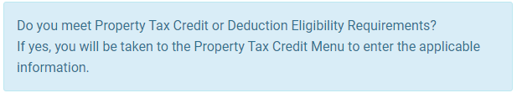
No matter what the correct answer to this question is, please answer “NO”. We will work on the NJ return once we are finished with the Federal return.

Step 1d New Jersey Return – Health Care
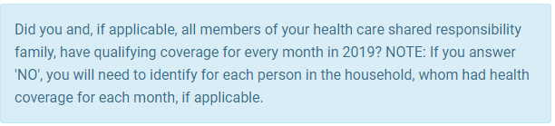
No matter what the correct answer to this question is, please answer “YES”. We will work on the NJ return once we are finished with the Federal return.

Step 1e New Jersey Return – Basic Info
Next, you will get a screen with various NJ Basic Information questions.
Do not answer any of these questions now – just click “CONTINUE”

Step 1f Dependents or Qualifying Person(s)
Enter information for dependent(s).
Federal AGI: 0 Federal Refund: 0 NJ Refund: 0

Step 2 W-2
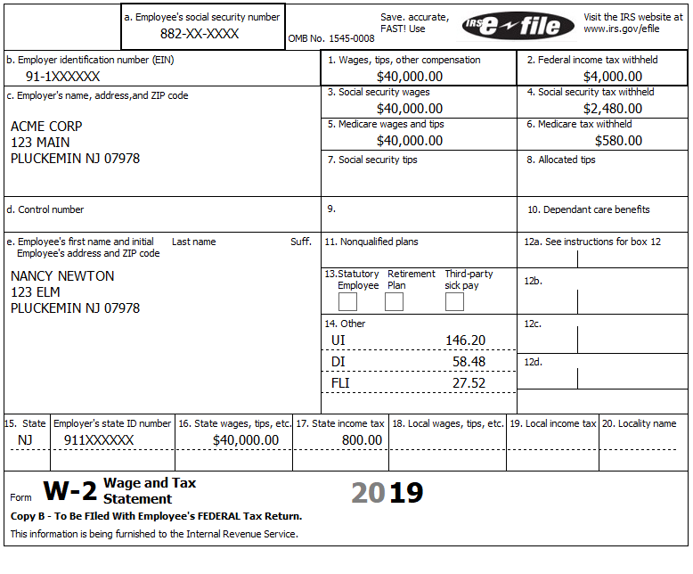
Federal AGI: 40,000 Federal Refund: 4,033 NJ Refund: 658
Note: Nothing new here except the new max Box 14 values

Step 3 Alimony Received
Nathan received alimony of 3,600. The agreement was modified to conform to TCJA (Tax Cuts and Job Act of 2017) on 07-01-2019.
Federal AGI: 40,000 Federal Refund: 4,033 NJ Refund: 595
Q: Why did the Federal info stay the same, but the NJ Refund changed?

Step 4 Alimony Paid
Nancy paid alimony of 3,700. The Recipient’s SSN is 884-xx-xxxx. The agreement was modified to conform to TCJA on 07-01-2019.
Federal AGI: 40,000 Federal Refund: 4,033 NJ Refund: 660

Step 5 Sch A
The Newtons paid 5,000 for medical and dental insurance.
Federal AGI: 40,000 Federal Refund: 4,033 NJ Refund: 732
Note: The Sch A line 3 is only 7.5% of AGI.

Step 6 Tuition
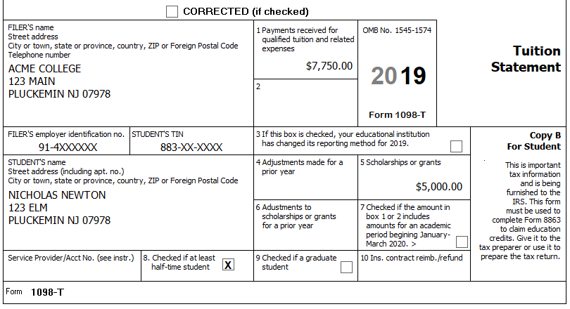
Nathan and Nancy paid $2,750 for Niko’s college tuition plus an additional $3,500 for room and board. They spent $250.00 on course related textbooks and supplies (which were not an enrollment requirement) plus $500.00 for a new computer (Some of Niko’s courses required that he submit homework assignments and interact with instructors online).
Niko did not receive a 1098-T for 2018. This is Niko’s first year in his (undergraduate) college degree program. Niko has no felony convictions of any kind. Niko has not claimed any education credit on 4 prior tax returns.
Reference: 4012 Tab J
Hint: Be sure to pick correct Eligible Student
Check: Values for each option:
 | Qualified Expenses | Federal Refund | NJ Refund
Tuition and Fees Deduction | 2,750 | 4,308 | 732
Lifetime Learning | 2,750 | 4,583 | 732
American Opportunity | 3,500 | 6,046 | 732

Federal AGI: 40,000 Federal Refund: 6,046 NJ Refund: 732

Step 7 Residential Energy Credit
This credit was reinstated by the Extender bill passed at the end of December, but TSO has not implemented it yet (as of 01-20-2020)
Federal AGI: 40,000 Federal Refund: 6,046 NJ Refund: 732

Step 8 Sch A
The PMI entry in Sch A, line 8d was reinstated by the Extender bill passed at the end of December, but TSO has not implemented it yet (as of 01-20-2020)
Federal AGI: 40,000 Federal Refund: 6,046 NJ Refund: 732

Step 9 Health Insurance (Federal)
The Newtons did not purchase health insurance via HealthCare.gov
Federal AGI: 40,000 Federal Refund: 6,046 NJ Refund: 732

State Section (New Jersey)
If TSO asks you the Property Tax question and the Health Care question when you start working on the NJ return, answer “NO” and “YES” respectively. We want to go through the NJ sections in the order they appear on the New Jersey Return screen.
As of 01-20-2020 TSO only recalculates the NJ refund when you exit click “EXIT NEW JERSEY RETURN” – you will need to do this between steps if you want to check your NJ Refund numbers.

Step 10a NJ Checklist – Basic Information
No extensions (federal or NJ) were filed.
Federal AGI: 40,000 Federal Refund: 6,046 NJ Refund: 855

Step 10b NJ Checklist – Income Subject to Tax
Federal AGI: 40,000 Federal Refund: 6,046 NJ Refund: 855

Step 10c NJ Checklist – Subtractions from Income
Federal AGI: 40,000 Federal Refund: 6,046 NJ Refund: 855

Step 10d NJ Checklist – Credits
Q: What questions did you ask to determine if they met the Property Tax Eligibility Requirements?
Federal AGI: 40,000 Federal Refund: 6,046 NJ Refund: 905

Step 10e NJ Checklist – Tax
Hint: Use the NJ HCC / SRP Worksheet
Hint: Entering info into TSO is required for all people on the return
Federal AGI: 40,000 Federal Refund: 6,046 NJ Refund: 146
Q: For what months does Nathan need an exemption?
Q: What exemption might Nathan qualify for?
Q: How do you answer the YES/NO question for Nathan for the months of May – August?
Q: Is Nancy’s SRP payment based on the flat rate amount or the income % amount?

Step 10f NJ Checklist – Payments
Federal AGI: 40,000 Federal Refund: 6,046 NJ Refund: 146

Step 10g NJ Checklist – Miscellaneous Forms
Federal AGI: 40,000 Federal Refund: 6,046 NJ Refund: 146

